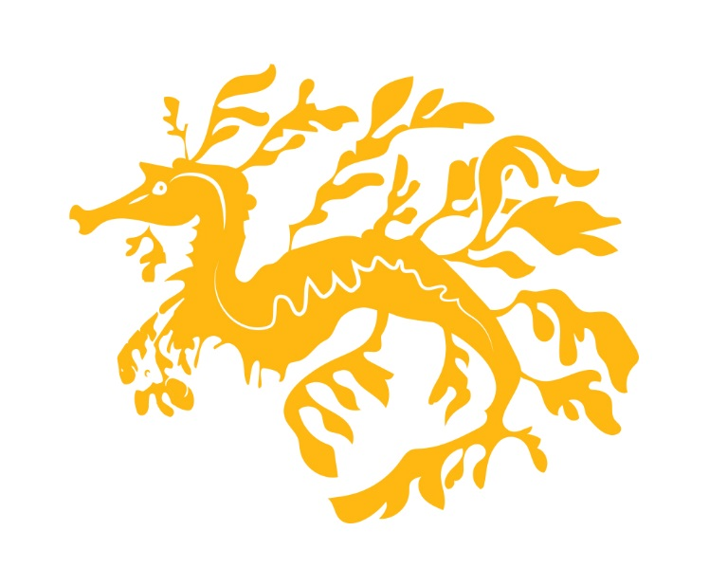
Allusion Wines – Order Form.

Order Details
 | Price | Quantity | Total
NV Sparkling Chardonnay | $18
2015 Sauvignon Blanc | $20
2016 Rose | $20
2013 Pinot Noir | $22
2014 Cabernet Sauvignon | $22
2013 Shiraz | $22

Free delivery on full cases (12 bottles)
Delivery Details
Name
Delivery Address
Suburb
State
Post Code
email
Phone
Delivery Instructions

Payment Details
Card Type (Visa/Mastercard)
Name on Card
Card Number
Expiry Date
CCV
Signature

Please complete this form and send to contact@allusionwines.com.au
You can also order over the phone by calling us on 08 8558 3333

